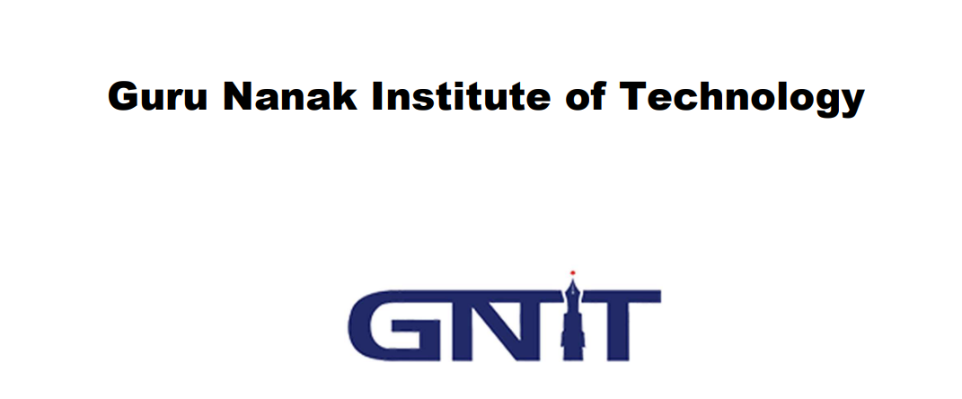
A Project submitted in partial fulfillment of
The requirement for the Honors’ Degree of
Bachelor of Computer Applications
under
MAKAUT University
Project Title : Face Guardian: Real-Time Facial Analysis and Attendance System
Paper Code: BCAD581
Year Of Examination: 2023
Submitted by
Name- Soumya Deep Saha
Roll No. - 31101221028
Reg No- 213111001210027 of 2021-22

Name- Sutanu Mukherjee
Roll No. - 31101221001
Reg No - 213111001210067 of 2021-22

Name- Ishita Sen
Roll No. - 31101221011
Reg No- 213111001210010 of 2021-22

Name- Shreshta Saha
Roll No. - 31101221044
Reg No- 213111001210043 of 2021-22

Final Project Report
Topic:- Guardian: Real-Time Facial Analysis and Attendance System

Submitted by:- Soumya Deep Saha, Sutanu Mukharjee, Ishita Sen, Shrestha Saha

Submitted To:- Ananjan Maity & Chiranjib Dutta
Subject name:- Industrial Training & Minor Project (BCAD581)

Index:-
1. Abstract ………………………………………………………. 5
2. Acknowledgement………………………………………… 5 - 6
3. SDK(kits)……………………………………………………….. 7 - 8
4. Model …………………………………………………………… 8 - 15
5. Machine Learning……………………………………………15
6. Supervised And Unsupervised…………………………16
7. Python…………………………………………………………… 17
8. Workflow Project……………………………………………. 17 - 21
9. Source code and Output……………………………………………………. 21 - 24
10. Future scope……………………………………………………………………….. 25 - 26
11. Conclusion………………………………………………………………………. 27
12. Bibliography……………………………………………………………………… 27

1. Guardian: Real-Time Facial Analysis and Attendance System
The "Guardian" project introduces a cutting-edge Real-Time Facial Analysis and Attendance System designed to revolutionize traditional attendance tracking methods. Leveraging the power of facial recognition technology, this system offers dynamic and comprehensive analysis of facial features to not only mark attendance efficiently but also provide valuable insights into participant engagement during various activities.
Key Features:
- Facial Recognition:
  - The system employs OpenCV and face_recognition libraries to perform real-time facial recognition, enabling seamless identification of individuals.
- Facial Feature Analysis:
  - Beyond basic recognition, the system analyzes facial features such as head movement, eye states (open/closed), mouth states, and predicts gender using external APIs for a multifaceted understanding of attendee behavior.
- Dynamic Attendance Tracking:
  - Attendance is dynamically marked based on live facial analysis, eliminating the need for manual input. The system adapts to real-time changes in the environment and user presence.
- Glasses Detection:
  - A rudimentary glasses detection mechanism is integrated, assessing the position of eye landmarks to determine if an individual is wearing glasses.
- User-Friendly Interface:
  - The system features a user-friendly interface that provides real-time feedback on facial analyses and attendance status, enhancing user experience.
- Adaptability to Diverse Environments:
  - Robust preprocessing techniques and adaptability to varied environments ensure the system's reliability under different lighting conditions and facial orientations.
- Integration with Django:
  - The project demonstrates the integration of OpenCV functionalities within Django views for image processing, showcasing its potential in web applications.
2.Acknowledgement:-
SDT (Software Development Tools):- Machine Learning involves using algorithms to allow computer software program to ‘learn’ different tasks making use of the available data. ML program become more accurate the more they train on the relevant test data. Many types of software Development Tools are there. Some of them which used to programming are:-
1.Numpy:-
Work:-In Python we have lists that serve the purpose of arrays, but they are slow to process. NumPy aims to provide an array object that is up to 50x faster than traditional Python lists. The array object in NumPy is called ndarray, it provides a lot of supporting functions that make working with ndarray very easy. Arrays are very frequently used in data science, where speed and resources are very important.
Language: Python,C and C++.
2. OpenCV:-
Work:- OpenCV stands for "Open Source Computer Vision Library." It is an open-source computer vision and machine learning software library designed for image and video processing. OpenCV was originally developed by Intel and later supported by Willow Garage and Itseez (which was later acquired by Intel). The library is written in C++ and has interfaces for C++, Python, and Java.
3. face_recognition:-
Work:- face_recognition is a Python library built on top of the popular computer vision library OpenCV and the deep learning library dlib. It provides a simple and efficient way to perform face recognition tasks, including face detection and face identification, in images and videos.
4. genderize:-
genderize is a Python library that provides a simple interface to the Genderize.io API. Genderize.io is an external service that predicts the gender of a person based on their first name. The library allows you to send a list of names to the Genderize.io API, and it returns the likely gender associated with each name.
3.Software Development Kit (SDK)
As an AI language model, I can provide you with information about Google Colab and its software development kit (SDK).
Google Colab is a cloud-based interactive computing environment that provides free access to a Jupyter Notebook environment along with computational resources, including CPU, GPU, and TPU. It allows users to write, run, and share Python code in a collaborative and interactive manner. Colab is hosted on Google Drive, and notebooks can be created, shared, and saved directly in Google Drive.
While Google Colab does not have an official SDK, it provides a Python library called "google.colab" that allows developers to interact with the Colab environment programmatically. The "google.colab" library provides functionality for tasks such as importing and exporting files, installing Python packages, managing Colab sessions, and connecting to external services like Google Drive and Google Sheets.
Some of the common tasks that can be performed using the "google.colab" library include:
- Importing and exporting files:- The library allows you to upload and download files to and from the Colab environment. For example, you can use the "files.upload()" function to upload files from your local machine to Colab, and the "files.download()" function to download files from Colab to your local machine.

- Installing Python packages:- The library provides a way to install Python packages directly from within the Colab environment using the "!pip install" command.

- Managing Colabsessions:- The library allows you to manage the lifecycle of a Colab session. You can use functions like "drive.mount()" to mount your Google Drive, "drive.flush_and_unmount()" to flush and unmount the

Google Drive, and "os.kill()" to terminate the current session.Connecting to external services: The library provides functionality to connect to external services like Google Drive and Google Sheets, allowing you to read and write data to these services from within a Colab notebook.

- Interacting with ColabUI:- The library allows you to interact with the Colab user interface programmatically, for example, by using the "IPython.display" module to display images, videos, and other media in the output of a Colab cell.
Overall, while Google Colab does not have a standalone SDK, the "google.colab" library provides a convenient way to interact with the Colab environment programmatically and automate various tasks within Colab notebooks. You can import the "google.colab" library in your Python code and use its functions to perform operations within the Colab environment.
4.Model :-
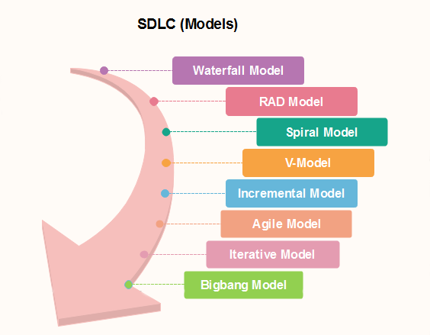
SDLC Model:-
- Waterfall Model:-
The waterfall is a universally accepted SDLC model. In this method, the whole process of software development is divided into various phases.

The waterfall model is a continuous software development model in which development is seen as flowing steadily downwards (like a waterfall) through the steps of requirements analysis, design, implementation, testing (validation), integration, and maintenance.

Linear ordering of activities has some significant consequences. First, to identify the end of a phase and the beginning of the next, some certification techniques have to be employed at the end of each step. Some verification and validation usually do this mean that will ensure that the output of the stage is consistent with its input (which is the output of the previous step), and that the output of the stage is consistent with the overall requirements of the system.

- RAD Model:-
RAD or Rapid Application Development process is an adoption of the waterfall model; it targets developing software in a short period. The RAD model is based on the concept that a better system can be developed in lesser time by using focus groups to gather system requirements.
- Spiral Model:-
The spiral model is a risk-driven process model. This SDLC model helps the group to adopt elements of one or more process models like a waterfall, incremental, waterfall, etc. The spiral technique is a combination of rapid prototyping and concurrency in design and development activities.

Each cycle in the spiral begins with the identification of objectives for that cycle, the different alternatives that are possible for achieving the goals, and the constraints that exist. This is the first quadrant of the cycle (upper-left quadrant).

The next step in the cycle is to evaluate these different alternatives based on the objectives and constraints. The focus of evaluation in this step is based on the risk perception for the project.

The next step is to develop strategies that solve uncertainties and risks. This step may involve activities such as benchmarking, simulation, and prototyping.

- V-Model:-
In this type of SDLC model testing and the development, the step is planned in parallel. So, there are verification phases on the side and the validation phase on the other side. V-Model joins by Coding phase.

- Incremental Model:-
The incremental model is not a separate model. It is necessarily a series of waterfall cycles. The requirements are divided into groups at the start of the project. For each group, the SDLC model is followed to develop software. The SDLC process is repeated, with each release adding more functionality until all requirements are met. In this method, each cycle act as the maintenance phase for the previous software release. Modification to the incremental model allows development cycles to overlap. After that subsequent cycle may begin before the previous cycle is complete.

- Agile Model:-
Agile methodology is a practice which promotes continues interaction of development and testing during the SDLC process of any project. In the Agile method, the entire project is divided into small incremental builds. All of these builds are provided in iterations, and each iteration lasts from one to three weeks.

- Iterative Model:-
It is a particular implementation of a software development life cycle that focuses on an initial, simplified implementation, which then progressively gains more complexity and a broader feature set until the final system is complete. In short, iterative development is a way of breaking down the software development of a large application into smaller pieces.

- Prototype Model:-
The prototyping model starts with the requirements gathering. The developer and the user meet and define the purpose of the software, identify the needs, etc.

A 'quick design'is then created. This design focuses on those aspects of the software that will be visible to the user. It then leads to the development of a prototype. The customer then checks the prototype, and any modifications or changes that are needed are made to the prototype.

Looping takes place in this step, and better versions of the prototype are created. These are continuously shown to the user so that any new changes can be updated in the prototype. This process continue until the customer is satisfied with the system. Once a user is satisfied, the prototype is converted to the actual system with all considerations for quality and security.
Machine Learning Life Cycle:-
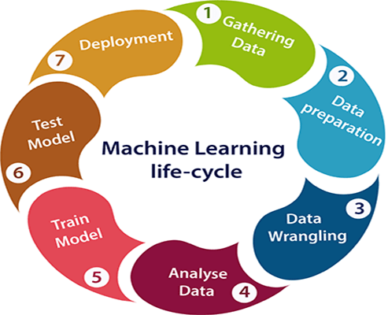

- Gathering Data:-
Data Gathering is the first step of the machine learning life cycle. The goal of this step is to identify and obtain all data-related problems.

In this step, we need to identify the different data sources, as data can be collected from various sources such as files, database, internet, or mobile devices. It is one of the most important steps of the life cycle. The quantity and quality of the collected data will determine the efficiency of the output. The more will be the data, the more accurate will be the prediction.

This step includes the below tasks:
- Identify various data sources
- Collect data
- Integrate the data obtained from different sources
By performing the above task, we get a coherent set of data, also called as a dataset. It will be used in further steps.
- Data preparation:-
After collecting the data, we need to prepare it for further steps. Data preparation is a step where we put our data into a suitable place and prepare it to use in our machine learning training.

In this step, first, we put all data together, and then randomize the ordering of data.
This step can be further divided into two processes:
- Data exploration:-
It is used to understand the nature of data that we have to work with. We need to understand the characteristics, format, and quality of data.

A better understanding of data leads to an effective outcome. In this, we find Correlations, general trends, and outliers.
- Data pre-processing:-
Now the next step is preprocessing of data for its analysis.

- Data Wrangling:-
Data wrangling is the process of cleaning and converting raw data into a useable format. It is the process of cleaning the data, selecting the variable to use, and transforming the data in a proper format to make it more suitable for analysis in the next step. It is one of the most important steps of the complete process. Cleaning of data is required to address the quality issues.

It is not necessary that data we have collected is always of our use as some of the data may not be useful. In real-world applications, collected data may have various issues, including:
- Missing Values
- Duplicate data
- Invalid data
- Noise
So, we use various filtering techniques to clean the data.

It is mandatory to detect and remove the above issues because it can negatively affect the quality of the outcome.

- Data Analysis:-
Now the cleaned and prepared data is passed on to the analysis step. This step involves:
- Selection of analytical techniques
- Building models
- Review the result
The aim of this step is to build a machine learning model to analyze the data using various analytical techniques and review the outcome. It starts with the determination of the type of the problems, where we select the machine learning techniques such as Classification, Regression, Cluster analysis, Association, etc. then build the model using prepared data, and evaluate the model.

Hence, in this step, we take the data and use machine learning algorithms to build the model.

- Train Model:-
Now the next step is to train the model, in this step we train our model to improve its performance for better outcome of the problem.

We use datasets to train the model using various machine learning algorithms. Training a model is required so that it can understand the various patterns, rules, and, features.

- Test Model:-
Once our machine learning model has been trained on a given dataset, then we test the model. In this step, we check for the accuracy of our model by providing a test dataset to it. Testing the model determines the percentage accuracy of the model as per the requirement of project or problem.

- Deployment:-
The last step of machine learning life cycle is deployment, where we deploy the model in the real-world system.

If the above-prepared model is producing an accurate result as per our requirement with acceptable speed, then we deploy the model in the real system. But before deploying the project, we will check whether it is improving its performance using available data or not.

The deployment phase is similar to making the final report for a project.

5.Machine Learning:-
ML-based deep learning can simplify the task of crop breeding. Algorithms simply collect field data on plant behavior and use that data to develop a probabilistic model.
Crop yield prediction is another instance of machine learning in the agriculture sector. The technology amplifies decisions on what crop species to grow and what activities to perform during the growing season. Tech-wise, crop yield is used as a dependent variable when making predictions.
The major factors include temperature, soil type, rainfall, and actual crop information. Based on these inputs, ML algorithms like neural networks and multiple linear regression produce forecasts.

6.Supervised and Unsupervised Learning:-
The goal of this research is to present a comparison between different clustering and segmentation techniques, both supervised and unsupervised, to detect plant and crop rows.
Aerial images, taken by an Unmanned Aerial Vehicle (UAV), of a corn field at various stages of growth were acquired in RGB format through the Agronomy Department at the Kansas State University. Several segmentation and clustering approaches were applied to these images, namely K-Means clustering, Excessive Green (ExG) Index algorithm, Support Vector Machines (SVM), Gaussian Mixture Models (GMM), and a deep learning approach based on Fully Convolutional Networks (FCN), to detect the plants present in the images. A Hough Transform (HT) approach was used to detect the orientation of the crop rows and rotate the images so that the rows became parallel to the x-axis.
The result of applying different segmentation methods to the images was then used in estimating the location of crop rows in the images by using a template creation method based on Green Pixel Accumulation (GPA) that calculates the intensity profile of green pixels present in the images. Connected component analysis was then applied to find the centroids of the detected plants. Each centroid was associated with a crop row, and centroids lying outside the row templates were discarded as being weeds.
A comparison between the various segmentation algorithms based on the Dice similarity index and average run-times is presented at the end of the work.

7.Python:-
Python is also being used for developing the IoT devices. AI is assisting IoT in enabling real-time data analytics to help make informed decisions
to farmers. Precision agriculture or smart Agriculture relies on emerging technologies such as AI, ML and data analytics to revolutionize farming practices.
8.Workflow project:-
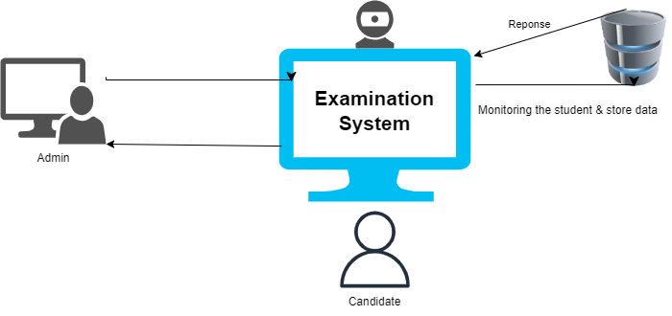
9.Workflow management of Face detection
Managing a face detection and employee data entry system is essential to ensure its effectiveness and security. Here's a description of the management aspects of the diagram:
- System Administration:
  - Admin Panel: The Admin Panel is the central hub for managing the system. It allows authorized administrators to perform various tasks:
    - User Access Control: Admins can grant and revoke access to different features of the system for specific users or user roles.
    - Employee Data Management: Admins can add, modify, or delete employee records, ensuring that the database remains up-to-date.
    - System Configuration: System settings such as camera parameters, face recognition thresholds, and notification preferences can be configured through the admin panel.
    - Access Logs Review: Administrators can access and review logs of entries and exits, helping them monitor system activity and identify anomalies.
- Employee Data Entry:
  - Data Input: Admins or designated personnel can use the Employee Data Entry Interface to input and update employee information. This interface ensures that the database contains accurate and current employee records.
  - Data Validation: Admins should establish data validation rules to ensure the quality and consistency of employee data, preventing errors and duplicate entries.
- Camera Management:
  - Camera Health: Regularly monitor the status of CCTV cameras or hardware components to ensure they are functioning correctly. Implement maintenance schedules and troubleshoot issues promptly.
  - Camera Placement: Optimize camera placement for maximum coverage while respecting privacy regulations and ethical considerations.
- Database Maintenance:
  - Backup and Recovery: Regularly back up the database to prevent data loss in case of system failures. Establish recovery procedures to minimize downtime.
  - Data Security: Implement robust security measures to protect the employee data stored in the database. This includes encryption, access control, and vulnerability assessments.
- Face Detection and Recognition:
  - Algorithm Updates: Stay informed about updates and improvements in face detection and recognition algorithms. Periodically update the system to benefit from advancements in the field.
  - Threshold Tuning: Adjust the face recognition threshold to balance between false positives and false negatives, depending on the specific security requirements.

- Security and Compliance:
  - Privacy Compliance: Ensure that the system complies with relevant data privacy regulations, such as GDPR or HIPAA, to protect individuals' rights and privacy.
  - Cyber security: Continuously monitor and enhance the system's cyber security to prevent unauthorized access and data breaches.

- User Training and Support:
  - Provide training to administrators and users to ensure they can effectively operate the system.
  - Offer technical support to address any issues or questions users may have.
- Reporting and Analysis:
  - Implement reporting tools that allow administrators to generate reports on system usage, employee attendance, and security incidents.
  - Analyze these reports to identify patterns, trends, and areas for improvement.
By effectively managing the face detection and employee data entry system, you can ensure its reliability, security, and compliance with regulations, ultimately contributing to a safer and more efficient environment for your organization. Regular maintenance and updates are key to keeping the system running smoothly and securely.

10.Source code:-
# Load images from the 'student_images' folder
path = 'student_images'
images = []
classNames = []
mylist = os.listdir(path)
for cl in mylist:
curImg = cv2.imread(f'{path}/{cl}')
images.append(curImg)
classNames.append(os.path.splitext(cl)[0])
# Encode faces from the loaded images
def findEncodings(images):
encodeList = []
for img in images:
img = cv2.cvtColor(img, cv2.COLOR_BGR2RGB)
encoded_face = face_recognition.face_encodings(img)[0]
encodeList.append(encoded_face)
return encodeList
encoded_face_train = findEncodings(images)
# Function to calculate the angle between two points
def angle_between_points(p1, p2):
return np.arctan2(p2[1] - p1[1], p2[0] - p1[0]) * 180.0 / np.pi
# Function to mark attendance in the CSV file
# Function to mark attendance in the CSV file
def markAttendance(name, head_movement_angle, left_eye_state, right_eye_state, mouth_state, glasses_state, gender):
file_path = 'output.csv'
with open(file_path, 'a') as f:
# Check if the file is empty, and if so, write headers
if f.tell() == 0:
f.write("Name,Head Movement,Left Eye,Right Eye,Mouth,Glasses,Gender,Date,Time\n")

now = datetime.now()
date = now.strftime('%d-%B-%Y')
time = now.strftime('%I:%M:%S:%p')
if name == "No person":
f.write(f'{name},{head_movement_angle},{left_eye_state},{right_eye_state},{mouth_state},{glasses_state},{gender},{date},{time}\n')
else:
f.write(f'{name},{head_movement_angle:.2f} degrees,{left_eye_state},{right_eye_state},{mouth_state},{glasses_state},{gender},{date},{time}\n')
# Function to calculate the head movement angle
def calculate_head_movement_angle(landmarks):
# Extract relevant landmarks for head movement calculation
left_eye_center = np.mean(landmarks['left_eye'], axis=0)
right_eye_center = np.mean(landmarks['right_eye'], axis=0)
# Calculate the head movement angle
head_movement_angle = angle_between_points(left_eye_center, right_eye_center)
return head_movement_angle
# Function to calculate the eye aspect ratio (EAR)
def eye_aspect_ratio(eye):
# Calculate the Euclidean distances between the vertical eye landmarks
vertical_dist1 = np.linalg.norm(np.array(eye[1]) - np.array(eye[5]))
vertical_dist2 = np.linalg.norm(np.array(eye[2]) - np.array(eye[4]))

# Calculate the Euclidean distance between the horizontal eye landmarks
horizontal_dist = np.linalg.norm(np.array(eye[0]) - np.array(eye[3]))
# Calculate the eye aspect ratio
ear = (vertical_dist1 + vertical_dist2) / (2.0 * horizontal_dist)
return ear
# Function to calculate the mouth aspect ratio (MAR)
def mouth_aspect_ratio(mouth):
# Ensure the mouth landmarks are valid
if len(mouth) != 6:
return 0.0
# Calculate the Euclidean distances between the vertical mouth landmarks
vertical_dist1 = np.linalg.norm(np.array(mouth[1]) - np.array(mouth[5]))
vertical_dist2 = np.linalg.norm(np.array(mouth[2]) - np.array(mouth[4]))
# Calculate the Euclidean distance between the horizontal mouth landmarks
horizontal_dist = np.linalg.norm(np.array(mouth[0]) - np.array(mouth[3]))
# Calculate the mouth aspect ratio
mar = (vertical_dist1 + vertical_dist2) / (2.0 * horizontal_dist)
return mar

Screenshot of the working project:-
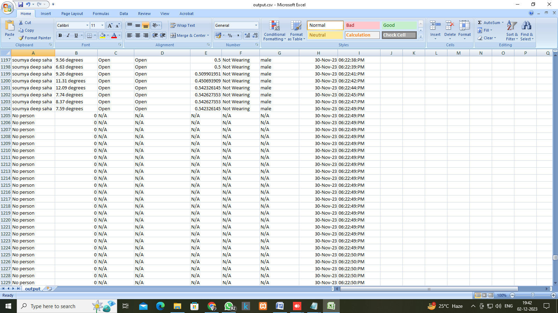
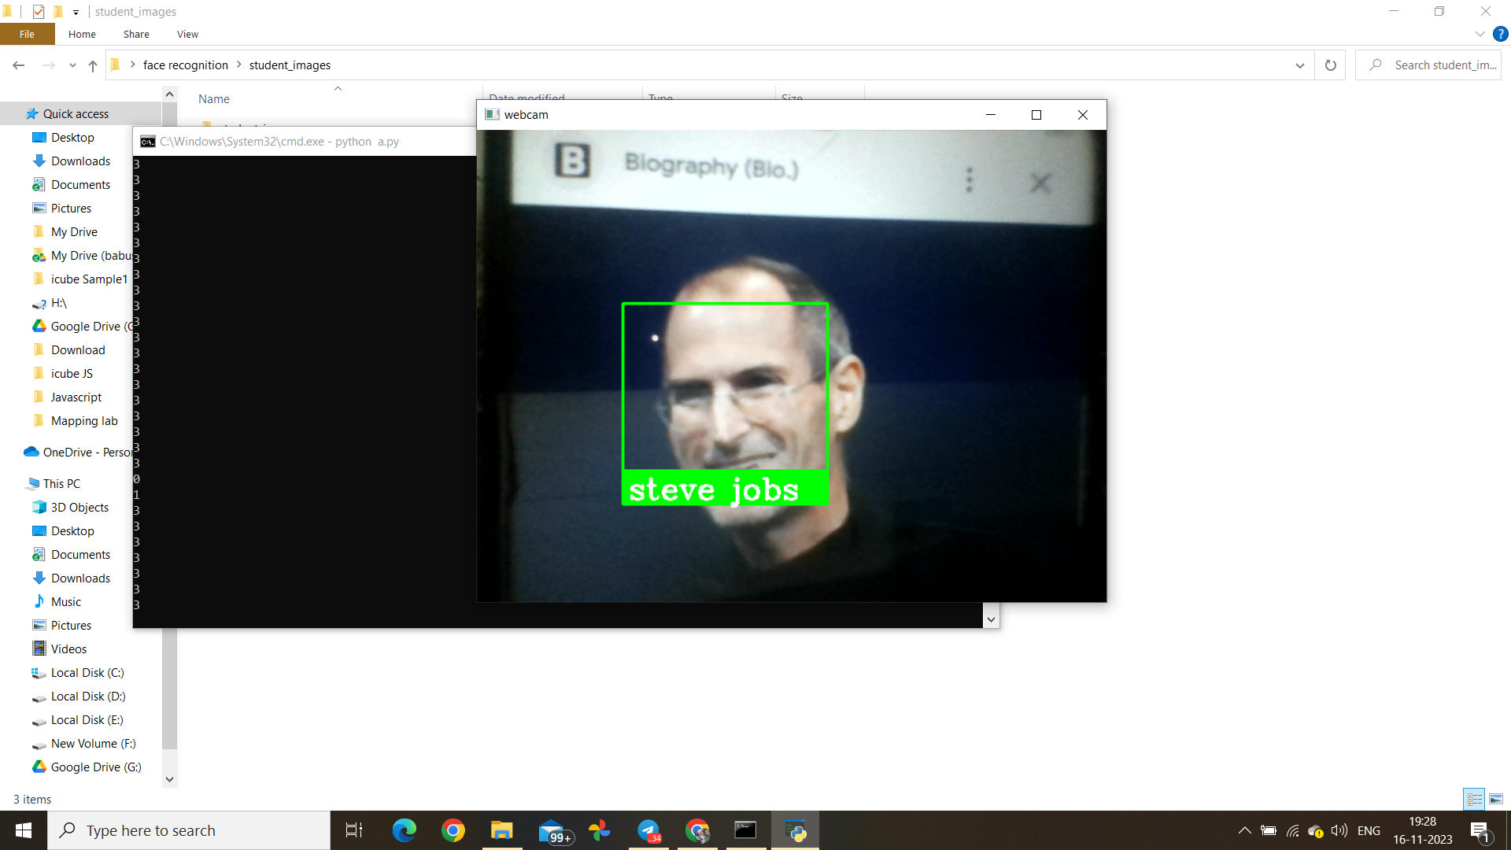

11.Future Scope of this project:-

- Real-time Face Recognition System: Develop a real-time face recognition system that can identify and classify faces in a live video feed, either for security or personal use.
- Face Mask Detection: Create a system that can detect whether a person is wearing a mask or not by analyzing their face. This could be used for enforcing mask mandates in public places.
- Emotion Detection and Analysis: Build a project that detects and analyzes facial expressions to determine a person's emotional state. This can have applications in marketing, mental health, and user experience design.
- Attendance Management System: Develop a face detection-based attendance system for schools or businesses that automates the process of taking attendance by recognizing the faces of students or employees.
- Smart Doorbell with Face Detection: Design a smart doorbell that can detect and notify homeowners of familiar or unfamiliar faces at their doorstep, enhancing security and convenience.
- Face-Based Access Control: Implement a face detection system for secure access to a building, room, or computer, replacing traditional keys or passwords.
- Facial Biometric Authentication: Build a project that uses face recognition as a biometric authentication method for securing smartphones, computers, or online accounts.
- Interactive Art Installation: Create an interactive art installation that responds to the emotions or movements of people's faces, creating an engaging and immersive experience.
- Parental Control and Child Safety: Design a system that can alert parents or guardians if their child's face is detected in potentially unsafe online content, helping to ensure child safety on the internet.

12.conclusion
In conclusion, our face detection project successfully achieved its objectives, demonstrating efficient real-time detection. Challenges were addressed, and opportunities for improvement identified. Ethical considerations were paramount. Future work may involve enhanced accuracy and broader applications, emphasizing privacy and fairness.
13. Bibliography
1. Application of Machine Learning written by Shreshta Saha
2.Data Visualization and workflow written by Ishita Sen, Soumya Deep Saha
3.Python Data Analytics(with opencv ,numpy, face_recognition) written by Sutanu Mukherjee

